WebClicker User Manual

This manual will highlight the major features of WebClicker.

# Home Page

Visiting webclicker.tk takes you directly to the WebClicker homepage. The two most important uses of WebClicker are creating and taking polls, so we make those tasks easy by highlighting a large “Create a Poll” button, and allowing the user to navigate to polls by either manually entering the access code, or by selecting from a list of recent public polls.

### Create Poll

To create a poll, click on the “Create Poll” button, then follow the instructions in the Create Poll section.

### Navigate to Poll

To take a poll, enter the poll’s access code and hit Enter OR select a poll from the filterable list of recent public polls. Then, follow the instructions in the Take Poll section.

### Sign-Up / Sign-In / Sign-Out

You can also sign up, sign in, or sign out, from the home page. To do this, expand the divider that gives your user information (ex. You are not logged in.), and then select which action you want to perform. You can only sign in to one account at a time, so the options will depend on your current user information. Then, follow the instructions for your selected action.

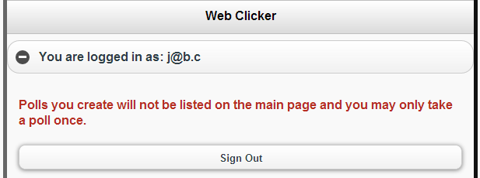 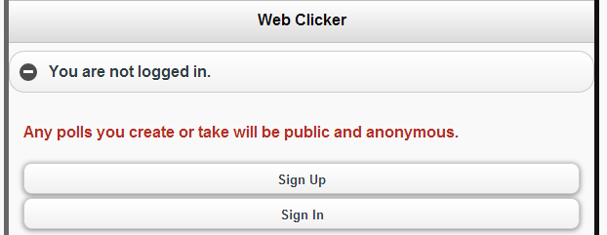

Finally, you can also take the WebClicker Feedback poll or visit our “About” page for more information on the project and team, a link to our GitHub repository, and the site statistics.

# Create a Poll

When creating a poll, your first choice will be what to name the poll. WebClicker generates random default names for polls, but feel free to set your own.

You can also set the optional settings by expanding the “Poll Options...” section. Here you can set parameters like when whether it is active or not, and what group it will be created under. Polls created in the ‘public’ group will be visible to all users.

Polls can have up to 1-10 questions, and you can add or remove questions by the Add Question and Delete Question buttons below the list of questions. Each question requires a question to ask the user, and then a selection of answer type: textbox, radio, and checkbox. Textbox answers will allow the user to enter a text response; Radio answers allow the user to select 1 answer from a list of 2-5 responses; Checkbox answers allow the user to select any number of answers from a list of 2-5 responses. You can add and remove responses to radio or checkbox answers by using the add and remove buttons visible when creating such answers. You can even set the correct responses for checkbox and radio questions by selecting the correct responses as if you were taking the poll.

When creating a poll, you cannot have any empty text fields. The poll title, poll questions, and poll responses are required. To finish creating a poll, click the “All Done!” button.

After creating a poll, you will see the poll details screen. This will display: the access code, a link to share the poll, the number of questions, the number of responses, and the date and time that the poll was created. You can also go directly to taking the poll, or viewing the poll results.

# Share a Poll

If you are an anonymous user: Use the access code or link from the poll details page after poll creation, or find the poll using the filterable list of recent public polls.

If you are a logged in user: Use the access code or link from the poll details page after poll creation, or find the poll in your list of created polls on the user page.

# Take Poll

When taking a poll, users must know if they are logged in or not, and as which account. The user’s login information is shown at the top-right corner of the page. There is also a “Home” button at the top-left of the page, to return to the home page at any time.

The user begins the poll at the first question. Each question is displayed as it’s own page, with the current question being highlighted in the list of questions near the top of the page. Each page is simply the question text, and the question’s input field with custom responses.

Users can navigate between questions in the poll in a number of ways. There are “Previous” and “Next” buttons at the bottom of pages where there are previous and next pages. Mobile users can use swipe gestures to navigate between previous and next pages as well. There is also the list of questions displayed at the top of each page, so you can navigate directly to any question in the poll.

To submit a poll, navigate to the last question page and click the “Submit Poll” button at the bottom right of the page.

# View Poll Results

Poll results can be accessed in a number of ways.

Users will be presented the results of a poll immediately after taking a poll.

Poll creators receive a link to the poll results page from the poll details page after creating a poll, and both the results page and details page of a poll can be accessed by the poll creator’s poll management page.

# Create Groups

From the homepage, expand the user information content at the top of the page, and then click the “Group Subscriptions” button. This will take you to the user’s poll managment page where you can create a new group and see a list of the polls you own.

You can also see a list of your owned polls, separated by group. From this list, you can take the poll, view the results, view the details, or deactivate the poll.

# Group Subscriptions

From the homepage, expand the user information content at the top of the page, and then click the “Group Subscriptions” button. This will take you to the Group Subscriptions page where you can subscribe to new groups, unsubscribe from subscribed groups, and see the polls from your subscribed groups.

To subscribe to a new group, expand the the “Subscribe to a group” content, then find the group from the filterable list of groups, enter the password, and click the “Subscribe” button.

To unsubscribe from a group, find the group from the list of your group subscriptions, expand it’s content, and click the “Unsubscribe” button.

To view the results or take a poll from a group, find the group from the list of your group subscriptions, expand it’s content, find the poll from the list of the group’s polls, and click the corresponding button.